Practical 2
Aim:- Use var, let, const, and demonstrate basic features like template literals and destructuring; build a billing calculator with user input.
Software/Tools Required: VS Code , Web Browser
Experiment program code:
Calculator.html:-
// Use var, let, const, and demonstrate basic features like template literals and destructuring; build a billing calculator with user input.
<!DOCTYPE html>
<html>
<head>
<title>Billing Calculator</title>
</head>
<body>
<h2>Billing Calculator</h2>

<script>
// const example
const GST = 0.18;

//user Input
var customerName = prompt("Enter Customer Name:");
var productName = prompt("Enter Product Name:");

// var example
var quantity = Number(prompt("Enter Quantity:"));
let price = Number(prompt("Enter Price per Item:"));

//Calculations
let total = quantity * price;
let gstAmount = total * GST;
let finalBill = total + gstAmount;

//Object
const bill = {
customer: customerName,
product: productName,
quantity,
price,
total,
gstAmount,
finalBill
};

//Destructuring
const {
customer,
product,
gstAmount: gst,
finalBill: amountz
} = bill;

//Output using Template Literals
document.write(`<h3>Billing Receipt</h3>`);
document.write(`<p>Customer: ${customer}</p>`);
document.write(`<p>product: ${product}</p>`);
document.write(`<p>Quantity: ${quantity}</p>`);
document.write(`<p>Price per Item: ₹${price}</p>`);
document.write(`<p>GST (18%): ₹${gst.toFixed(2)}</p>`);
document.write(`<p>Final Bill: ₹${amount.toFixed(2)}</p>`);

</script>
</body>
</html>

Output:- 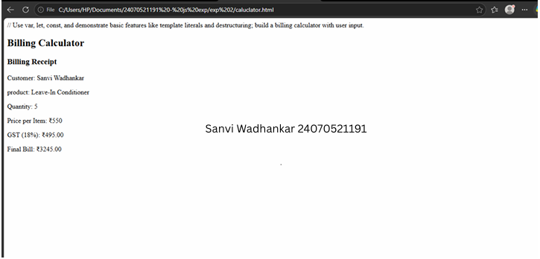

Case Study
Case Study Title:- Develop the webpage for an online shopping website with using HTML,CSS and HTML5 tags
Software/Tools Used:- VScode , Web Browser

Code:-
<!DOCTYPE html>
<html>
<head>
<title>Online Shopping - Bill Calculator</title>
</head>
<body>

<h1>Online Shopping Store - Bill Calculator</h1>

<form id="billForm">

<label for="custName">Customer Name</label><br>
<input type="text" id="custName" required><br><br>

<label for="mobile">Mobile Number</label><br>
<input type="tel" id="mobile" required><br><br>

<label for="invoice">Invoice Number</label><br>
<input type="text" id="invoice" required><br><br>

<label for="product">Product Name</label><br>
<input type="text" id="product" required><br><br>

<label for="quantity">Quantity (in Kg)</label><br>
<input type="number" id="quantity" step="0.1" required><br><br>

<label for="rate">Rate per Kg (Rs.)</label><br>
<input type="number" id="rate" step="0.01" required><br><br>

<label for="discount">Discount (%)</label><br>
<input type="number" id="discount" step="0.1" value="0"><br><br>

<label for="gst">GST (%)</label><br>
<input type="number" id="gst" step="0.1" value="0"><br><br>

<label for="packing">Packing Charges (Rs.)</label><br>
<input type="number" id="packing" step="0.01" value="0"><br><br>

<label for="payment">Payment Mode</label><br>
<select id="payment">
<option value="Cash">Cash</option>
<option value="Card">Card</option>
<option value="UPI">UPI</option>
</select><br><br>

<label for="membership">Membership</label><br>
<select id="membership">
<option value="No">No</option>
<option value="Yes">Yes</option>
</select><br><br>

<button type="button" onclick="calculateBill()">Calculate Bill</button>
</form>

<div id="result"></div>

<script>
// INTERNAL JS (inbuilt script inside the HTML file)

function calculateBill() {
// Reading input values - all inputs return strings, so we convert them
// using Number() to demonstrate type conversion
let custName = document.getElementById("custName").value; // string
let mobile = document.getElementById("mobile").value; // string
let invoice = document.getElementById("invoice").value; // string
let product = document.getElementById("product").value; // string

let quantity = Number(document.getElementById("quantity").value); // number
let rate = Number(document.getElementById("rate").value); // number
let discount = Number(document.getElementById("discount").value); // number
let gst = Number(document.getElementById("gst").value); // number
let packing = Number(document.getElementById("packing").value); // number

let payment = document.getElementById("payment").value; // string
let membership = document.getElementById("membership").value === "Yes"; // boolean

// Basic validation
if (!custName || !mobile || !invoice || !product || quantity <= 0 || rate <= 0) {
console.error("Validation failed: Please fill all required fields correctly.");
alert("Please fill all required fields with valid values.");
return;
}

// Calculation
const subtotal = quantity * rate;
const discountAmount = (subtotal * discount) / 100;
const afterDiscount = subtotal - discountAmount;
const gstAmount = (afterDiscount * gst) / 100;

// Extra membership discount (const used since this value won't change)
const membershipDiscount = membership ? afterDiscount * 0.05 : 0;

let totalBill = afterDiscount + gstAmount + packing - membershipDiscount;

console.log("----- Bill Calculation -----");
console.log("Customer: " + custName);
console.log("Subtotal: Rs. " + subtotal.toFixed(2));
console.log("Discount Amount: Rs. " + discountAmount.toFixed(2));
console.log("GST Amount: Rs. " + gstAmount.toFixed(2));
console.log("Membership Discount: Rs. " + membershipDiscount.toFixed(2));
console.log("Total Bill: Rs. " + totalBill.toFixed(2));

// Display result
document.getElementById("result").innerHTML =
"<hr>" +
"<p><strong>Customer:</strong> " + custName + " (" + mobile + ")</p>" +
"<p><strong>Invoice No:</strong> " + invoice + "</p>" +
"<p><strong>Product:</strong> " + product + " (" + quantity + " Kg)</p>" +
"<p><strong>Subtotal:</strong> Rs. " + subtotal.toFixed(2) + "</p>" +
"<p><strong>Discount:</strong> Rs. " + discountAmount.toFixed(2) + "</p>" +
"<p><strong>GST:</strong> Rs. " + gstAmount.toFixed(2) + "</p>" +
"<p><strong>Packing Charges:</strong> Rs. " + packing.toFixed(2) + "</p>" +
"<p><strong>Membership Discount:</strong> Rs. " + membershipDiscount.toFixed(2) + "</p>" +
"<p><strong>Payment Mode:</strong> " + payment + "</p>" +
"<p><strong>Total Bill: Rs. " + totalBill.toFixed(2) + "</strong></p>";
}
</script>

</body>
</html>

Output:-
